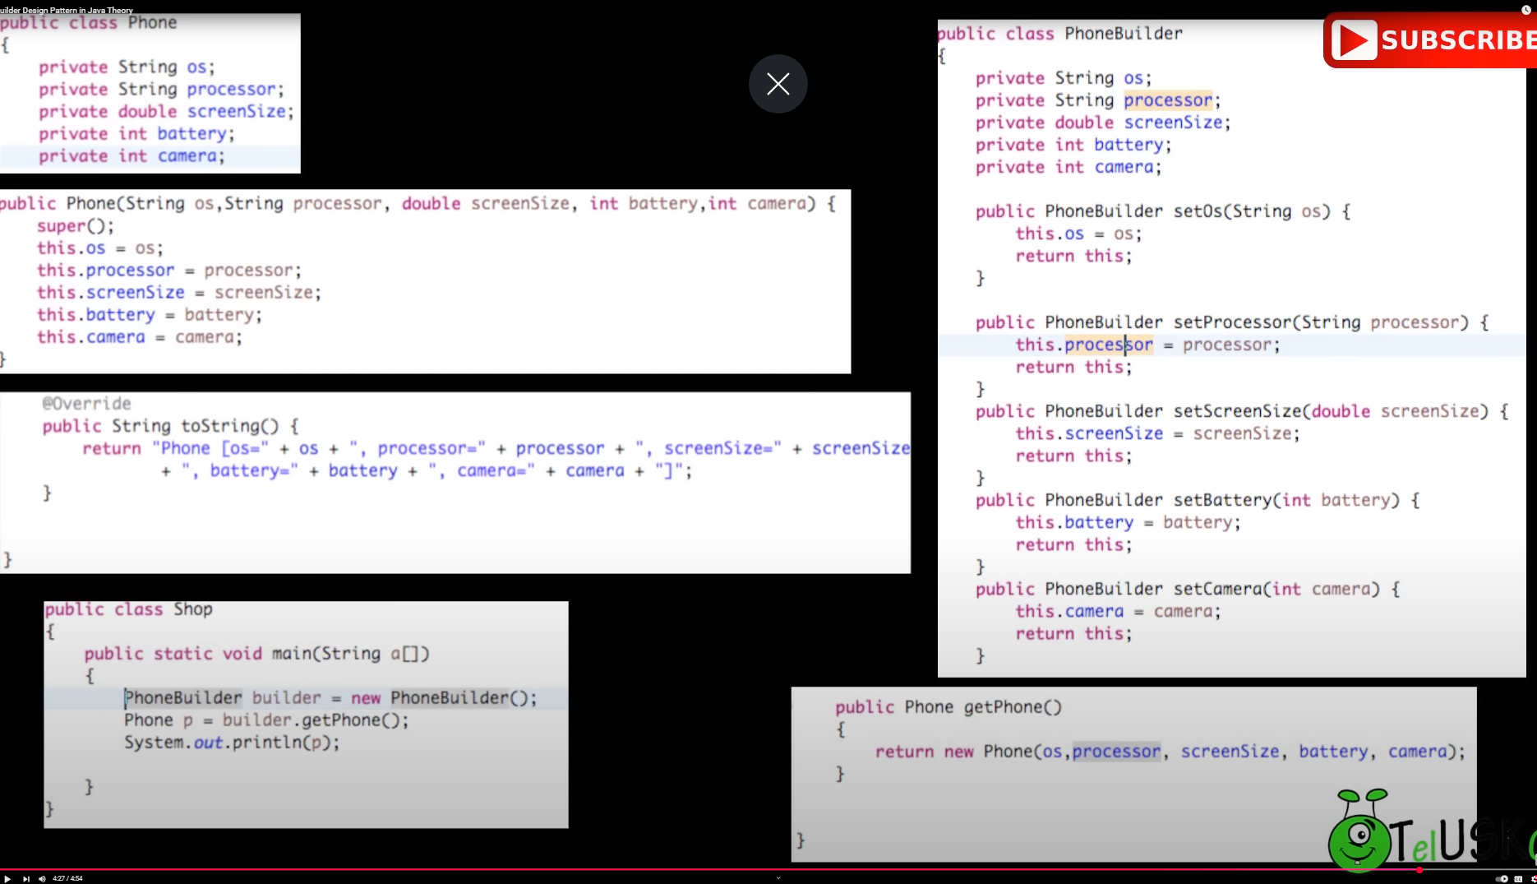

The **Builder Pattern** is a design pattern that allows you to construct complex objects step by step. It is particularly useful when an object needs to be created with many possible configurations, and you want to separate the construction process from the actual representation of the object.

